Superstar Sports

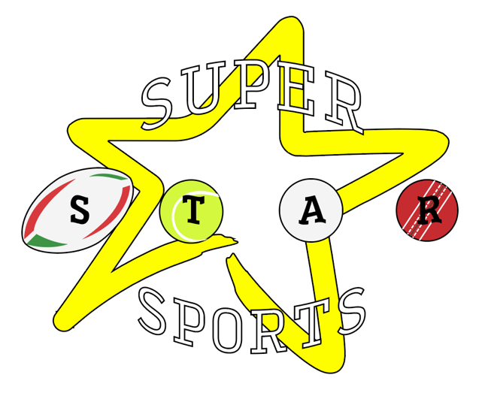

Behaviour Policy

Behaviour Policy

The best interests of the child must be a top priority in all actions concerning children. This policy is a statement of the aims, principles and strategies for positive behaviour management. We recognise that all children have the right to feel safe and secure; all children have a right to the best opportunity to work hard, be happy and to make good progress.
We recognise all the protected characteristics of the Equality Act 2010 and commit to respect them. We aim to prevent all forms of discrimination, harassment and victimisation related to the protected characteristics for all members of the community. We avoid using physical intervention whenever possible. We always follow the DfE Guidance: Use of reasonable force.
Bullying of any kind is unacceptable at Superstar Sports Holiday Club.

Aims

To promote self-discipline and ensure good social and learning behaviour.
To create a community where everyone treats each other with respect.
To establish guidelines for excellent behaviour and ensure everybody follows them.
That everyone understands that bullying is not acceptable and what they should do if it occurs.
Children attending Superstar Sports Holiday Club have rights under the UN Convention on the Rights of the Child.
As a company, we feel that adopting positive behaviour management strategies is the most effective method to ensure the children under our care access their highest potential both physically and mentally. A system of rewards and sanctions is used to fulfil the aims of this policy:
Positive behaviours that may result in praise and rewards include:
- Kindness and consideration.
- Good friendship skills.
- Positive learning behaviours such resilience, perseverance, curiosity, independence, reflection and teamwork.
Unacceptable behaviours that may result in sanctions include:
- Aggression and violence towards pupils or adults.
- Rudeness or verbal abuse to pupils or adults.
- Purposely unsafe behaviour.
- Damage to property.
- Behaviour that would make it difficult for others to learn or enjoy themselves.
Systems used to support positive behaviour:
- Children will receive rewards in the form of Achievement, Progress, Teamwork and of the Day and Week certificates.
- Specific verbal praise - directed at positive learning and social behaviour.
- Messages home.
- Positive comments directed to children.
- Stickers, Trophies and Medals for achievements.
- Achievements celebrated via social media.
All sanctions and penalties are proportional, to determine a reasonable punishment the coach will take into account the child’s age, special educational needs or disability they may have and ay religious requirements affecting them – as stated in section 91 of the Education and Inspections Act 2006. We have the following system in place for our sanctions:
Stage 1 - Child receives a formal warning from the coach.
Stage 2 - Child is sent to Senior Coach (Site Lead) for 10 minute time out and explanation of further action (Yellow Card). Parent spoken to at end of the day.
Stage 3 - Parent/ guardian is informed of the seriousness of their misbehaviour and that and will asked to be collected (red card). Discussion with parent regarding whether child can continue to attend Superstar Sports Holiday Course on collection.
We will inform parents/carers of any sanctions received.
Restorative Meeting
Following some sanctions a restorative meeting may take place. The following is discussed:
What has happened?
Who has been affected?
How have they been affected?
What needs to happen to make things right? What will we do differently next time?
A commitment to the relationships between those in the room is reaffirmed.
Alternative and additional sanctions can be as follows:
- Verbal reprimand which may include a voice being controllably raised.
- Loss of privileges – for instance the loss of a prized responsibility or not having the same opportunities as peers in the year group.
Use of physical intervention
Physical Intervention is considered as a last resort to support young people in times of crisis:
- Physical Intervention should be avoided wherever possible.
- It is never a substitute for good behaviour management.
- Other methods of managing and de-escalating any situation which arises should be tried first, unless this is impractical.
- The main reason for intervening physically is to keep people safe.
This policy sets out the circumstances in which physical intervention might be appropriate and discusses the meaning of “reasonable force”. It adheres to section 550A of the Education Act 1996, and complies with the LA guidelines, including the Health and Safety at Work Act Planning to avoid Physical Intervention
At Superstar Sports we are proactive and plan to avoid Physical Intervention wherever possible. This is achieved through:
- Our Behaviour Policy, which promotes positive behaviour management strategies and outlines how a Positive Behaviour Management Plan might be used with specific children.
A Positive Behaviour Management Plan details how we arrange support in the areas of:
- Risk assessment
- Early intervention
- Preventative measures
- Proactive measures
- Planned support
Only staff who have undertaken training to use specific physical intervention techniques (eg. Team Teach) should be authorised to use these on young people. However, everyone has the right to use reasonable force to prevent an attack against themselves or others, whether they are formally authorised or not.
When to intervene with reasonable force?
The following categories would be considered legitimate situations in which to consider physical intervention as a last response:
- Committing a criminal offence.
- When there is risk of injury to self and/or others.
- When there is risk of significant damage to property.
Examples of situations in categories 1, 2 and 3:
- A child attacks a member of staff, or another child.
- Children are fighting.
- A child is engaged in, or is on the verge of committing, deliberate damage or vandalism to property.
In these situations, we would remove the class to a safe place rather than intervening physically.
- A child is causing, or at risk of causing, injury or damage by accident, by rough play, or by misuse of dangerous materials or objects.
- A child is running around the facilities in a way in which he or she might have or cause an accident likely to injure him or herself or others.
- A child persistently refuses to obey an instruction to leave a room.
- A child is behaving in a way that is seriously disrupting a lesson.
A child leaves the provision grounds
In this situation, we assign members of staff to watch out for the child’s safety. If the child leaves the grounds, we will not give chase, as this is likely to put the child in more serious danger – running across roads etc. We will follow the child calmly, asking the child to make the safe decision to come back into the building. We always contact parents if a child leaves the grounds, even if the child comes straight back. In more serious situations, we will also contact the police.
What is a reasonable force?
There is no legal definition of reasonable force, so it is not possible to set out comprehensively when it is reasonable to use force, or the degree of force that may reasonably be used. It will always depend on all the circumstances of the case. There are two relevant considerations:
The use of force can be regarded as reasonable only if the circumstances of the particular incident warrant it. The use of any degree of force is unlawful if the particular circumstances do not warrant the use of physical force. Therefore physical force could not be justified to prevent a pupil from committing a trivial misdemeanour, or in a situation that clearly could be resolved without force.
The degree of force employed must be in proportion to the circumstances of the incident and the seriousness of the behaviour or the consequences it is intended to prevent. Any force used should always be the minimum needed to achieve the desired result.
Is physical intervention necessary?
Before physically intervening we, wherever practicable, tell the child who is misbehaving to stop, and what will happen if he or she does not. We continue attempting to communicate with the pupil throughout the incident and should make it clear that physical intervention will stop as soon as it ceases to be necessary. A calm and measured approach to a situation is needed and we should never give the impression that we have lost our temper, or are acting out of anger or frustration, or to punish the child.
Recording incidents
We make a detailed, contemporaneous, written report of anywhere physical intervention is used. It may help prevent any misunderstanding or misrepresentation of the incident, and it will be helpful should there be a complaint. Immediately following any such incident the member of staff concerned should tell the Senior Coach (Site Lead) and provide a written report as soon as possible afterwards using the form in the Physical Intervention Guidelines for Schools. We inform parents formally and seek their cooperation, for example, by drawing up individual behaviour management programmes.
Date of next review: September 2024

