Superstar Sports

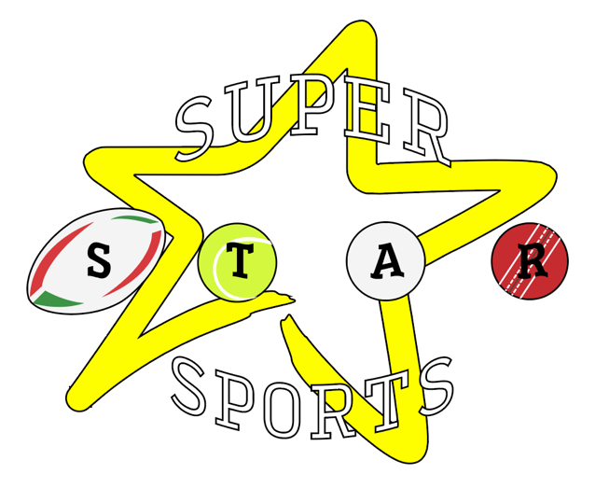

Modern Slavery Statement

ISSUED PURSUANT TO SECTION 54 OF THE MODERN SLAVERY ACT 2015
Modern Slavery Statement
Modern slavery, which includes human trafficking, is the illegal exploitation of people for personal or commercial gain. It can take various forms, including:
- Domestic exploitation;
- Labour exploitation;
- Organ harvesting;
- EU Status exploitation;
- Financial exploitation;
- Sexual exploitation1; and
- Criminal exploitation.
Superstar Sports is fully committed to preventing slavery and human trafficking in its business activities and across its supply chains – and to being open and transparent about any specific instances of slavery identified.
In line with best practice, and in compliance with Section 54 of The Modern Slavery Act 2015 (The Act), this statement sets out the actions taken by Superstar Sports to understand, prevent and address all modern slavery risks within its services (directly provided and commissioned) and supply chains.
More information about modern slavery, its types and prevalence can be found on the Local Authorities website:
https://www.modernslaverypartnership.org.uk/index.php.
http://southamptonlsab.org.uk/modern-slavery-2/

2. Organisation
Superstar Sports is a small, family run organisation which delivers a range of sport and performing arts services to clients across Hampshire.
Hampshire County Council is a large upper tier authority in the South East of England. It spends around £1.9 billion a year on serving Hampshire's 1.3 million residents across eleven districts/boroughs: Basingstoke and Deane, Eastleigh, East Hampshire, Fareham, Gosport, Hart, Havant, New Forest, Rushmoor, Test Valley and Winchester.
This statement directly supports the County Council’s Serving Hampshire Strategic Plan (2017-2021). This contains four strategic aims, including a commitment to ensuring people in Hampshire enjoy being part of strong, inclusive communities and can live safe, healthy and independent lives.
In achieving its objectives, the County Council provides a diverse range of public services delivered both in-house, through external contractors and in partnership. Consequently, the County Council has an equally diverse supply chain. For full information on the County Council’s organisational structure, please refer to its website: https://www.hants.gov.uk/aboutthecouncil/governmentinhampshire. Information on the County Council’s business activities and supply chains is set out in Appendix A.
This statement covers all activities of the County Council and encompasses direct employees, agency workers and services delivered on behalf of the County Council by third party organisations and in its supply chains.
3. Operation and Supply
Superstar Sports operates in the United Kingdom, where data suggests incidents of modern slavery are growing in prevalence. For example, according to the Government’s UK Annual Report on Modern Slavery, there was a 36% rise between 2017 (5,138) and 2018 (6,985) in the potential victims referred to the National Referral Mechanism. The number of modern slavery crimes recorded by the police grew by 49% between March 2018 and March 2019, when there were 5,059 recorded offences in England and Wales.
In this context, Superstar Sports remains vigilant and will take all steps available to manage risks presented.
All schools and organisation that works with Superstar Sports, which are covered by Section 54 of the Act, are expected to understand and comply with the Act’s requirements.
4. Responsibilities
Superstar Sports Management Team is responsible for ensuring appropriate recruitment, employment and purchasing policies are in place and reviewed on an annual basis.
The Company Director is responsible for ensuring that robust risk assessments are undertaken across relevant service areas where there is deemed to be a risk of modern slavery, including human trafficking.
The management team is responsible for ensuring that Superstar Sports policies - such as those relating to the recruitment of personnel or procurement of goods and services – are adhered to by staff, and that all relevant training relating to modern slavery is undertaken and kept up to date (see section eight below).
It is the responsibility of all staff to report any concerns regarding modern slavery.
5. Policies
Superstar Sports has policies and processes in place which support its commitment to preventing and tackling modern slavery throughout its business operations. All policies are subject to robust assurance processes and are reviewed on a regular basis to ensure they remain complaint and fit for purpose.
Employee code of conduct – Superstar Sports expects the highest standards of behaviour and ethical conduct from its employees. This code sets out the standards expected of staff when representing Superstar Sports. Any breaches are investigated, and action taken as necessary.
Expectations of Schools – Superstar Sports requires its partnership schools to provide safe working conditions where necessary, treat workers with dignity and respect, and act ethically and legally in their use of labour. Violations of these expectations will lead to review and investigation and ultimately may lead to the termination of the business relationship, if the school is found not to have taken appropriate corrective actions.
Pay – Superstar Sports operates a job evaluation system which is objective and non-discriminatory and supports the principles of equal pay. All Superstar Sports employees are in receipt of at least the UK minimum wage.
Emergency planning – Superstar Sports has a duty to partake in the multi-agency response to investigations into modern slavery by assisting victims.
Inclusion and diversity – Superstar Sports is committed to being a strong, inclusive community and continues to be an inclusive employer with a diverse workforce. Superstar Sports will support the aims of the Equality Act 2010. These are upheld by a range of policies and procedures designed to advance equality of opportunity and provide fair access and treatment in employment, the delivery of services and working.
Whistleblowing policy – Superstar Sports is committed to the highest standards of openness, probity and accountability. As such, employees, customers and other business partners are encouraged to report any concerns related to the direct activities, of the organisation. This includes any circumstances that may give rise to a heightened risk of modern slavery. Superstar Sports will endeavour to resolve such concerns without the need to raise a whistleblowing complaint – however, it is also recognised that this is sometimes necessary. The whistleblowing procedure is designed to make it easy for people to voice serious concerns without fear of harassment or victimisation.
6. Due diligence and risk management
Superstar Sports undertakes due diligence in both its recruitment processes.
Recruitment processes –Superstar Sports implements the recruitment policies and processes, which ensure that all prospective employees pre-employment checks in line with the latest UK guidance on Right to Work Checks (e.g. can confirm personal identifies and qualifications, are paid directly into an appropriate, personal bank account and can supply evidence of eligibility to work in the UK). All staff with responsibilities for recruitment and selection receive appropriate training, including their legal obligations under existing employment legislation.
7. Reporting suspicions of modern slavery
If Superstar Sports, suspects slavery or human trafficking activity within the organisation
it will be reported to the Hampshire Constabulary via the Modern Slavery Helpline (08000 121 700) . Concerns with regard to children are also reported through the Hampshire Multi-Agency Safeguarding Hub (MASH). Superstar Sports will also fulfil its statutory obligations to refer via the National Referral Mechanism where required.
8. Staff training and capacity building
All staff undertaking recruitment are required to complete Safer Recruitment eLearning. This includes information on how to recruit safely and mitigate the risk of modern slavery occurring in the supply of labour. The eLearning also signposts to a separate online learning tool intended to raise awareness of the signs of modern slavery and human trafficking.

Guidance can be found:
https://www.gov.uk/government/collections/modern-slavery
https://www.modernslaveryhelpline.org
https://www.nationalcrimeagency.gov.uk/what-we-do/crime-threats/modern-slavery-and-human-trafficking
https://www.hampshire-pcc.gov.uk/msp
http://southamptonlsab.org.uk/modern-slavery-2/

Legislation:
The Care Act 2014; the Children Act 1989; Working Together to Safeguard Children 2018

